You Are Cordially Invited To
Pete Piemonte & Steve Mulak Memorial
NSCA Open Sporting Clays Shoot
Saturday ~ September 7th, 2024
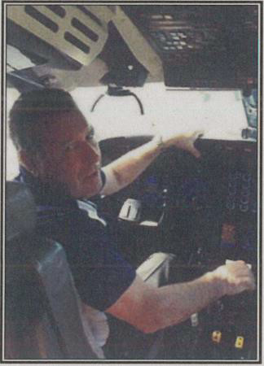

Hosted by the Western Mass. Bird Dog Club Inc.
87 Farnum
Road, Granville, MA
Saturday, September 7th, 2024
100 Target Main Event - No shot larger than 7-1/2, 1-1/8 oz., 12 gauge
$75.00 paid & received by September 1st, 2024

Trophies awarded in all classes.
Master Thru E Class
Also, Veterans, Super Veterans, Lady’s & Juniors
Hunter’s class trophy awarded to non-classed winner.
Please make check payable to WMBD Club, Inc. & Mail to: WMBDC – P.O. Box 82 – Chicopee, MA 01014 must be received by September 1st, 2024
This will be a “Shotgun” start at 10:00 am. & no one will be allowed on the course after 10:30 am.
You will be shooting 15 stations on one of the “premier woodlands course in New England” at the beautiful foothills of the Berkshires.
Shoot Offs for High Over All
(Management reserves the right to change the program at any time.)
Directions from North: -Mass. Pike East to Westfield exit - right off exit follow to Rt 20W - right onto Rt 20W follow to Rt 23N - left onto Rt 23 follow Rt 23 to Blandford Post Office - about 1.5 miles past the P.O. Take a left onto Beech Hill Rd. - follow to Maple Corner
Farm (3.5 miles) - take right at corner onto dirt road. - Follow to clubhouse.
Directions: -Rt 91N to exit 3 (Rt 5N) over bridge take 1st exit (Rt 57W) follow Rt 57W to Rt 57/10/2028 - take left onto 57/10/202 go 1/2 mile up and take right onto Rt 57W - follow (10.4 miles) to North Lane - take right onto North Lane - go 3 miles and take left onto Borden Brook Rd. - follow signs to Maple Corner Farm/Ski Touring Center. (1.7 miles) Bear left at corner onto dirt road - follow to clubhouse.

WESTERN MASS BIRD DOG CLUB PO BOX 82
CHICOPEE, MA 01014
